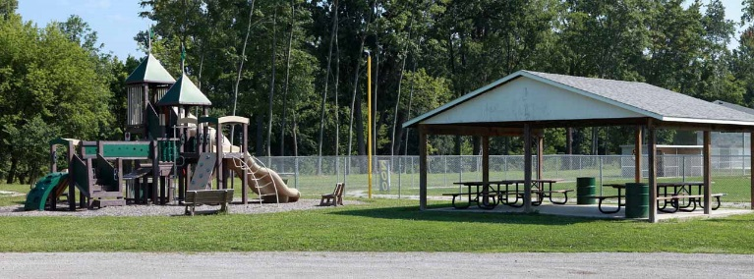
MONROEVILLE PARK & RECREATION

MONROEVILLE PARKS
RULES AND REGULATIONS

- A fee of $75.00 shall be required from anyone renting the large shelter house at Marsh Field Park ($50.00 rental fee + $25.00 deposit to guarantee rental of the shelter house and grounds). The other small shelters within the park system are also available for rental at a rate of $25.00 ($15.00 rental fee + $10.00 deposit.) The deposit shall be refunded if the shelter house and grounds have been satisfactorily cleaned by the renting party. A Village Parks employee shall inspect the shelter house and grounds to determine if it has been cleaned appropriately.

- Facilities shall be inspected following all regularly scheduled events (e.g., football games, softball games, baseball games, etc.). Any damage occurring to real estate or facilities shall be reported to the Monroeville Police Department for further investigation and action as deemed necessary.

- In accordance with ORC Ch. 1519, anyone using fireworks, other than a scheduled fireworks display, shall be reported to the Monroeville Police Department.

- All ATVs, go-karts, mini-bikes, dirt bikes, snowmobiles, and skateboards are strictly prohibited anywhere in the parks, except for maintenance use by authorized personnel.

- When the shelter house is rented no one other than the renters and their guests are to be in the shelter house at any time.

- Village softball fields, tennis courts, and sand volleyball courts may be rented for tournaments or other events.

- Anyone wishing to rent the fields or courts shall report to the Village Offices during normal working hours to sign the user contract and pay the appropriate fees. No field or court will be scheduled unless the requester can produce a copy of the signed contract and a receipt for fees from the Village Administrative Office. All information required to schedule the fields and courts will be provided at the time of the contract signing. Tournaments shall only be scheduled on an as-available basis and as authorized by the Village Parks Department.

- No league or any of its members shall have more than two tournaments per season.

- Any type of adult softball tournament shall have a recognized sanctioning body sponsoring the event. (ASA, USSSA, NSA)

- All warm-up and bat swinging will be in designated areas only.

- Due to safety considerations, sliding into 1st base shall not be permitted.

- All scheduling for use of facilities or grounds shall be scheduled through the Village Administrative Office. Residents of the Village of Monroeville may use all non-previously scheduled facilities on a first come first served basis. This does not include privately organized league play, tournaments, play-offs, matches, etc. which would preclude other village residents from using the parks. Any event that is scheduled through the Village Administrative Office and paid for in accordance with these Rules and Regulations shall take priority over non-fee public use.

- No alcohol shall be served, dispensed, or consumed, in any of the Village of Monroeville parks unless prior approval is obtained from the legislative body of the Village of Monroeville. In addition, all permits required by the Village of Monroeville and any other government entity must be obtained before the event. Appropriate security, at the discretion of the Monroeville Chief of Police, shall be in place. Anyone wishing to serve alcohol shall abide by all state and local laws concerning the responsible serving of alcoholic beverages. Event organizers shall be responsible for obtaining their liability insurance in an amount to be determined by the legislative body of Monroeville on a case-by-case basis.

- Organizers of special events are responsible for complying with Monroeville Resolution 99-29 concerning police special services.

- No camping day or overnight shall be permitted in any of the Village parks.

- No animals shall ever be allowed on the baseball and softball fields and all pets in other areas of the parks shall be controlled on a leash.

Revised 04/30/2020

